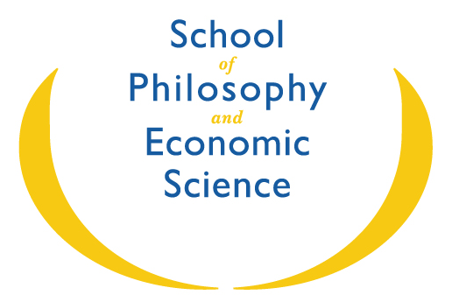
SCIENCE OF MEDITATION
Summer Term 2026
Meditation Readings from His Holiness
Sunday Mornings online at 8.30 am – 9.30 am:
17 May – 12 July (the last session for the Summer Term)
For anyone wishing to be added to the Sunday morning Zoom meeting list, please contact:
Dorothea Northfield scienceofmeditation.spes@gmail.com Tel: 020 8335 4291
Meditation Tutorials
Sunday Morning Tutorials at 10.00 and 11.00 am:
- 17 May – 12 July (the last session for the Summer Term)
- In-Person: (Highly recommended) at Mandeville Place
- Online: Available for those unable to travel
To arrange a Meditation Tutorial please contact:
Dorothea Northfield scienceofmeditation.spes@gmail.com Tel: 020 8335 4291
Meditation Residentials
Please see the main Notices

11 MANDEVILLE PLACE, LONDON, W1U 3AJ TEL: 020 7034 4000 FAX 020 7034 4010 WWW.SCHOOLECONOMICSCIENCE.ORG REGCHARITY NO. 313115

